Instance Pool with ORM stack

Contents

1. Introduction 3
2. Workflow diagram to deploy the stack 3
3. Create stack for Instance Pool 5
4. Plan the Job 9
5. Apply the Job 10
6. Verify in the Console 11
7. Destroy the stack 16

Introduction

Instance pools used to create and manage multiple compute instances within the same region as a group.
When create an instance pool, use an instance configuration as the template to create instances in the pool and also can attach existing instances to a pool by updating the pool.
Optionally, client can associate one or more load balancers and network load balancers with an instance pool. If client do this, when add an instance to the instance pool, the instance is automatically added to the load balancer's or network load balancer's backend set . After the instance reaches a healthy state (the instance is listening on the configured port number), incoming traffic is automatically routed to the new instance.
This resource provides the Instance Pool resource in Oracle Cloud Infrastructure Core service.

Workflow diagram to deploy the stack

Below diagram shows how the Terraform Artifact are applied in the OCI. While creating a ORM stack, using terraform deliverables Init, Plan and Apply is the flow to provision the resource in the OCI. We can have the deliverables in any of below.

- GitLab/GitHub Repo
- Bitbucket
- Can be in folder/.zip in the local disk
- Object Storage Bucket
- Can be in compartment
- Oracle provided Template


Prerequisites
- Appropriate IAM permissions to create and manage instance pools
- Image ocid
- subnet ocid
- CIDR block
- Availability Domain
- SSH Key

Create stack for Instance Pool

Go to OCI Console Developer Services Resource Manager Stacks select the compartment Create Stack

My Configuration Folder Browse Select the “instance pool” folder that contains the terraform Upload
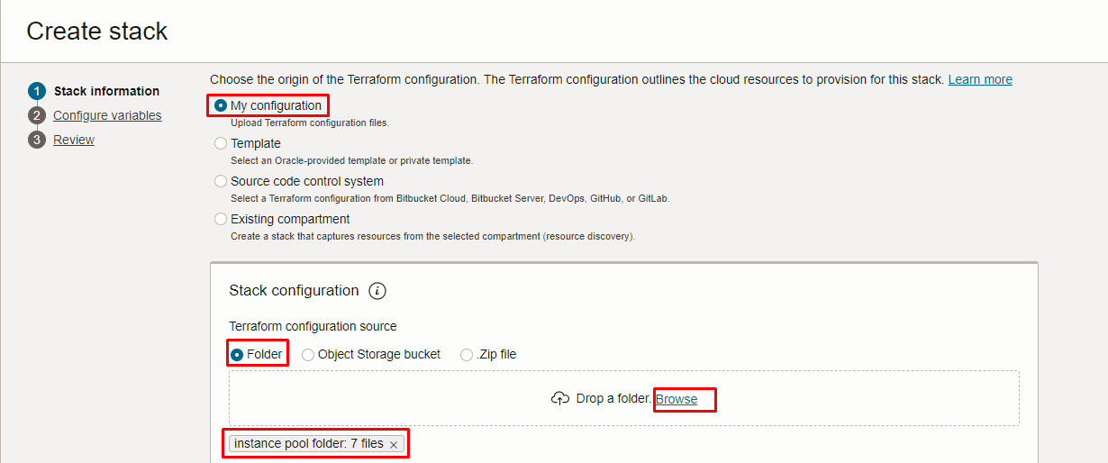

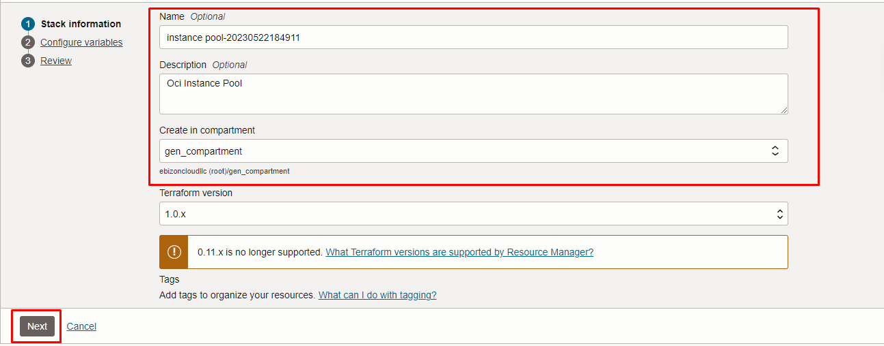
Click “NEXT”

Select the parameters as per the below screen,

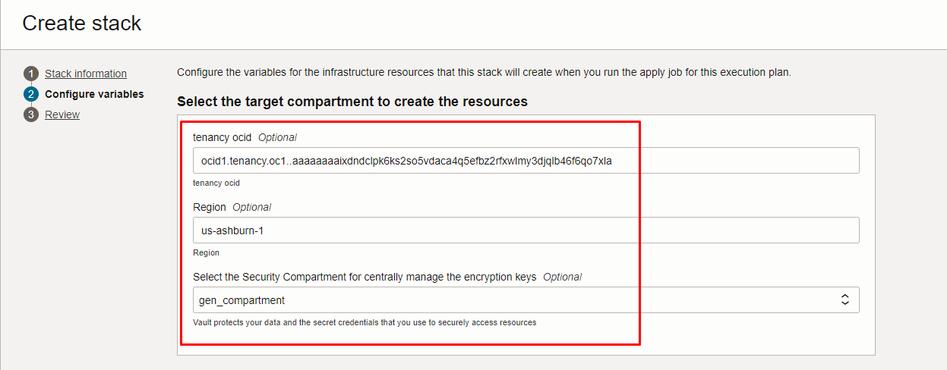

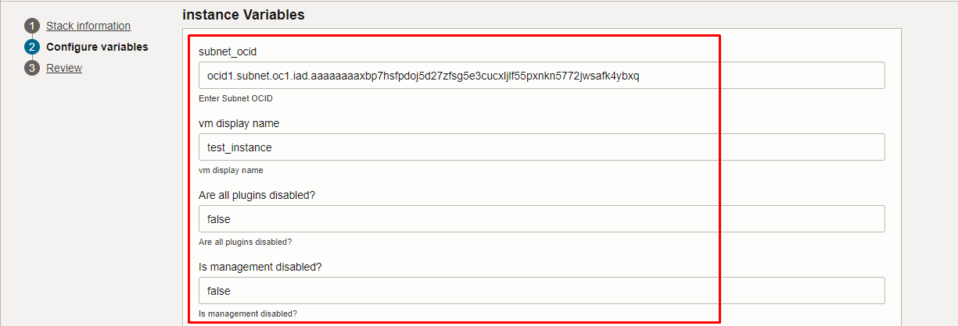

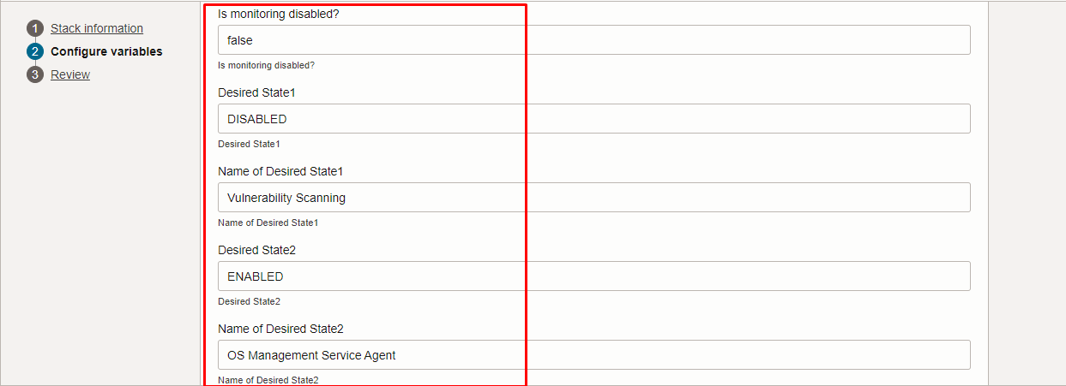

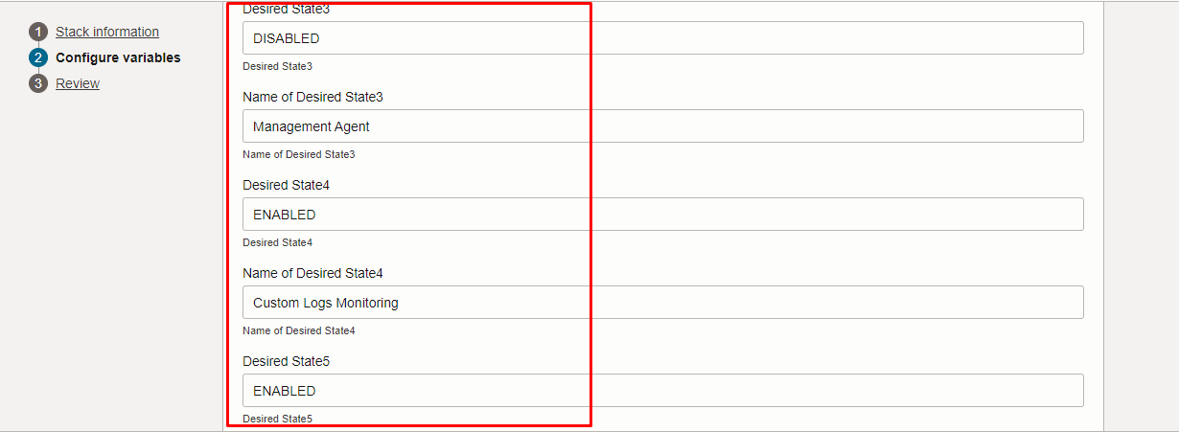
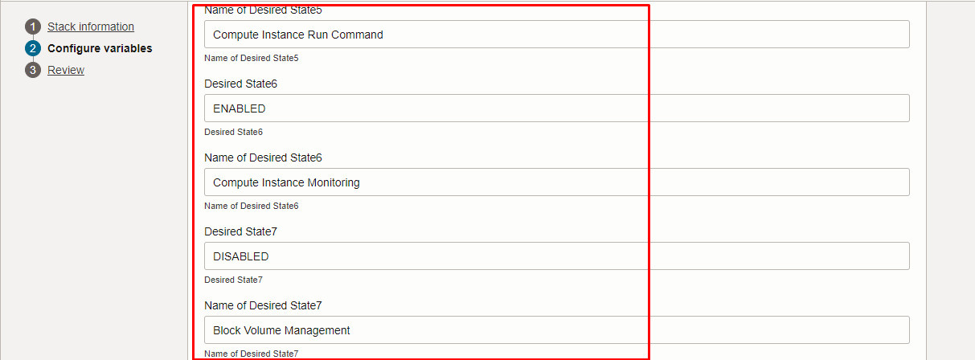
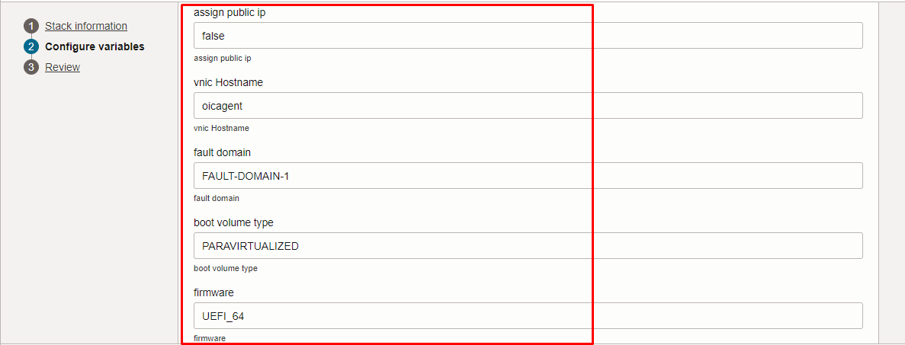
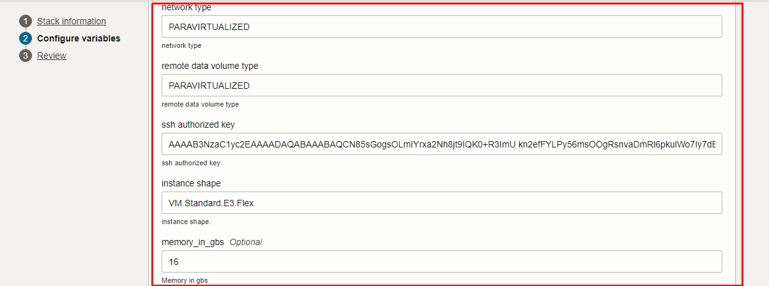

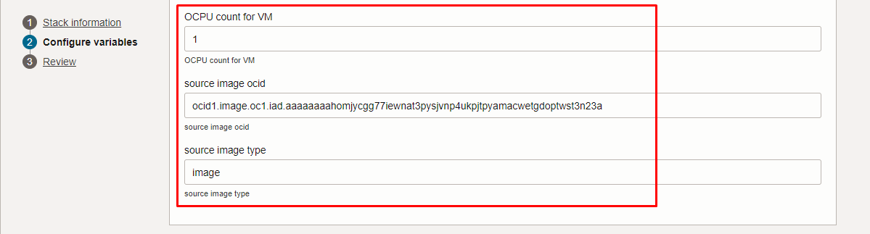

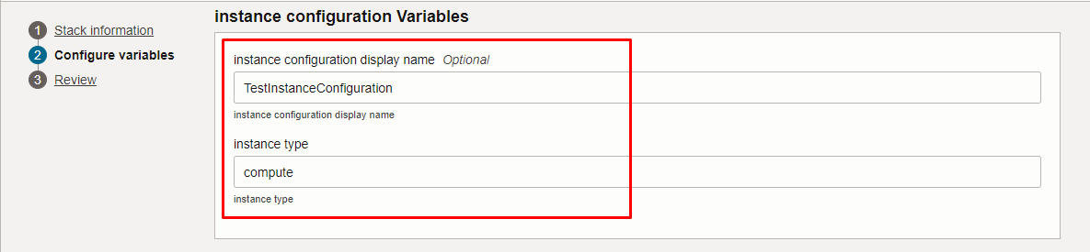

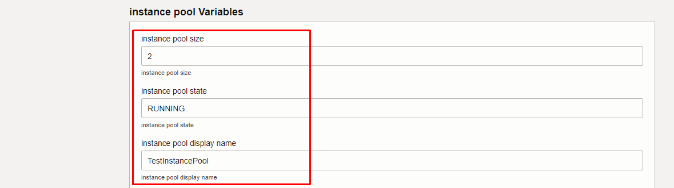

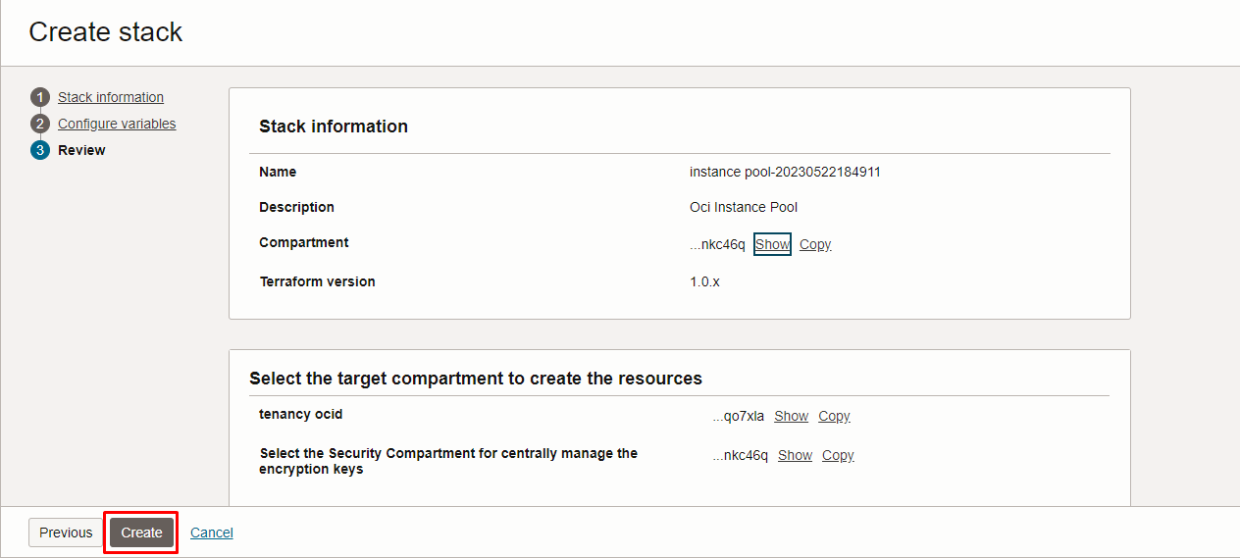

Click “NEXT” Click “CREATE”

Plan the Job

Click the “Plan”

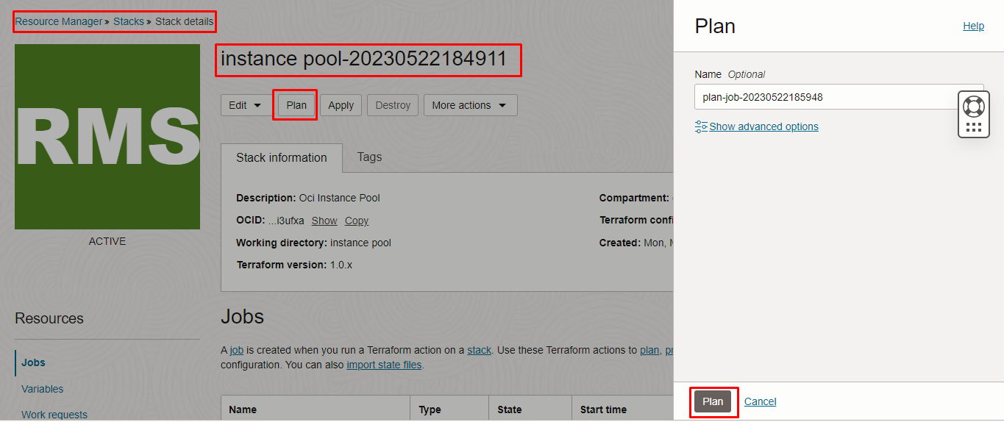

Verify the Plan is successful.
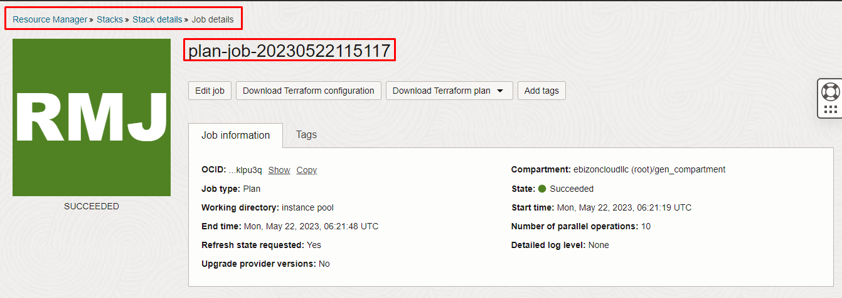

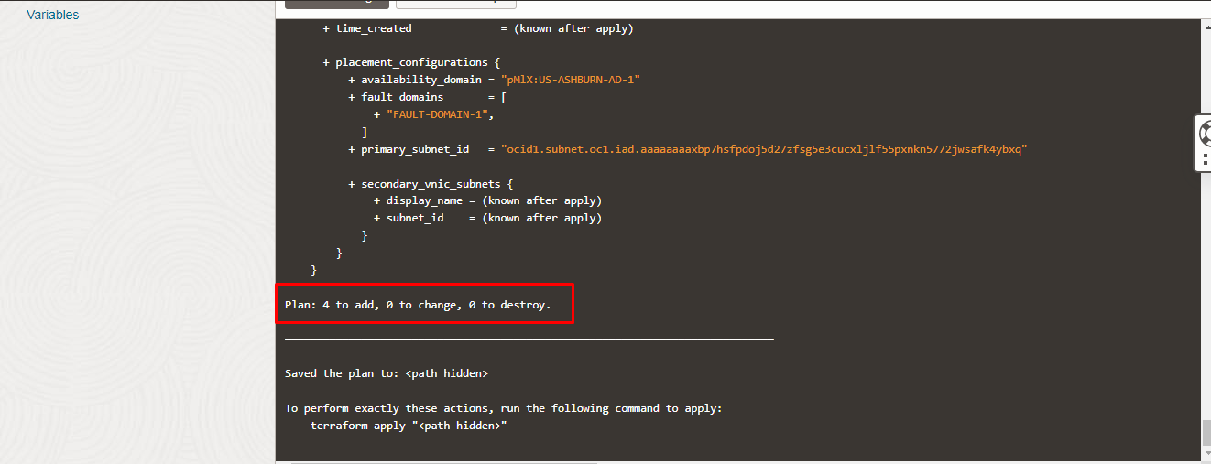

Apply the Job
Once the “plan” is success, now click “Apply”
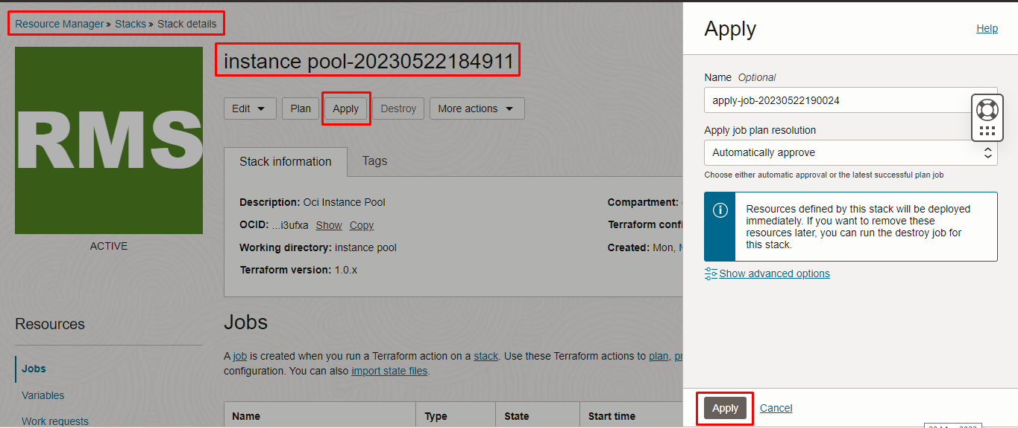

Verify the Apply is successful.

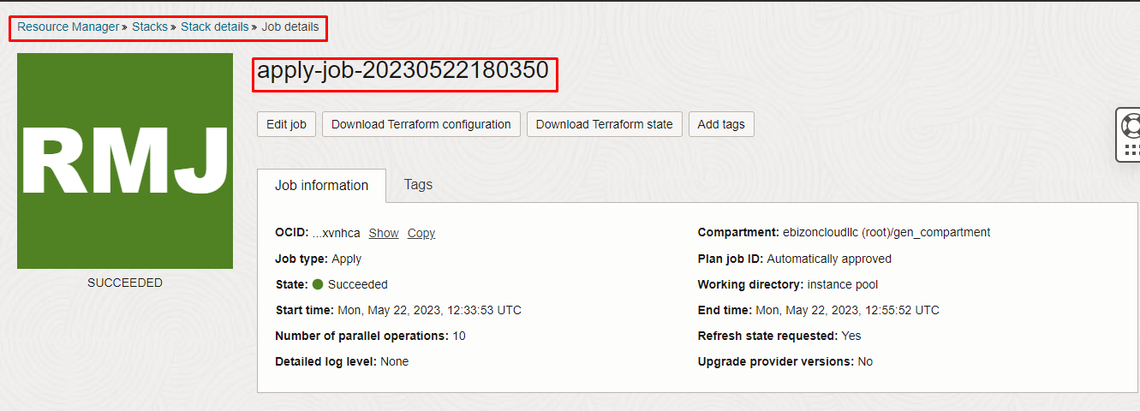
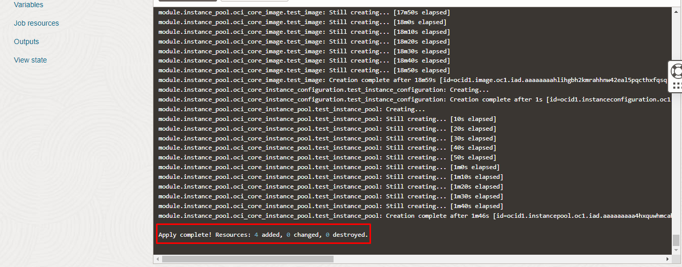

Verify in the Console
Go to OCI Console Compute Instances Instance Details
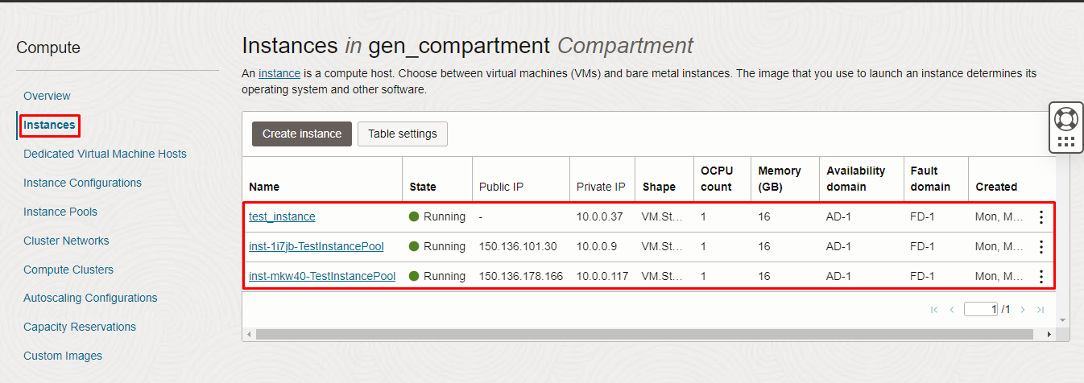
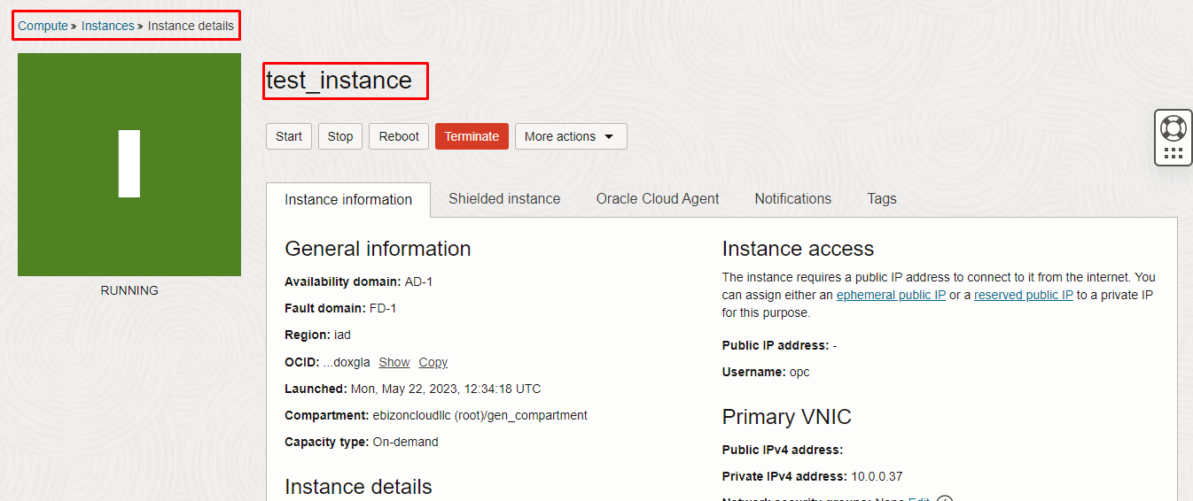
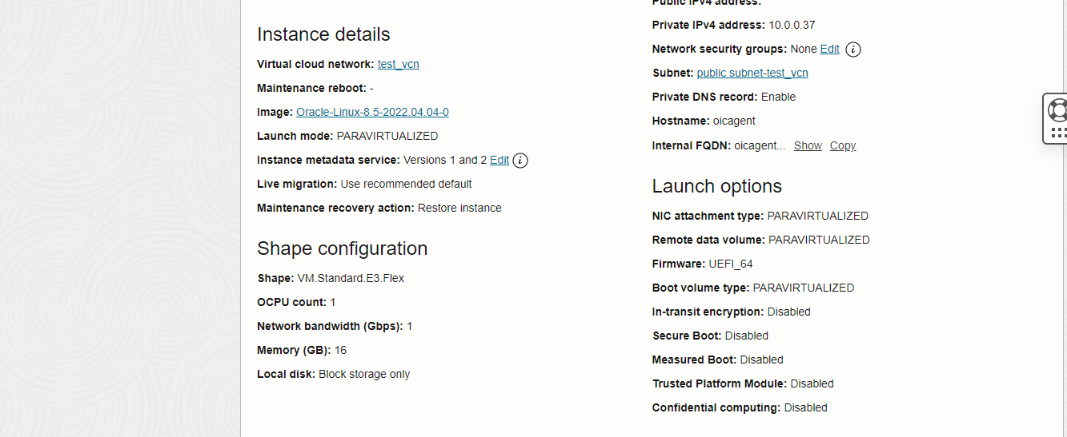
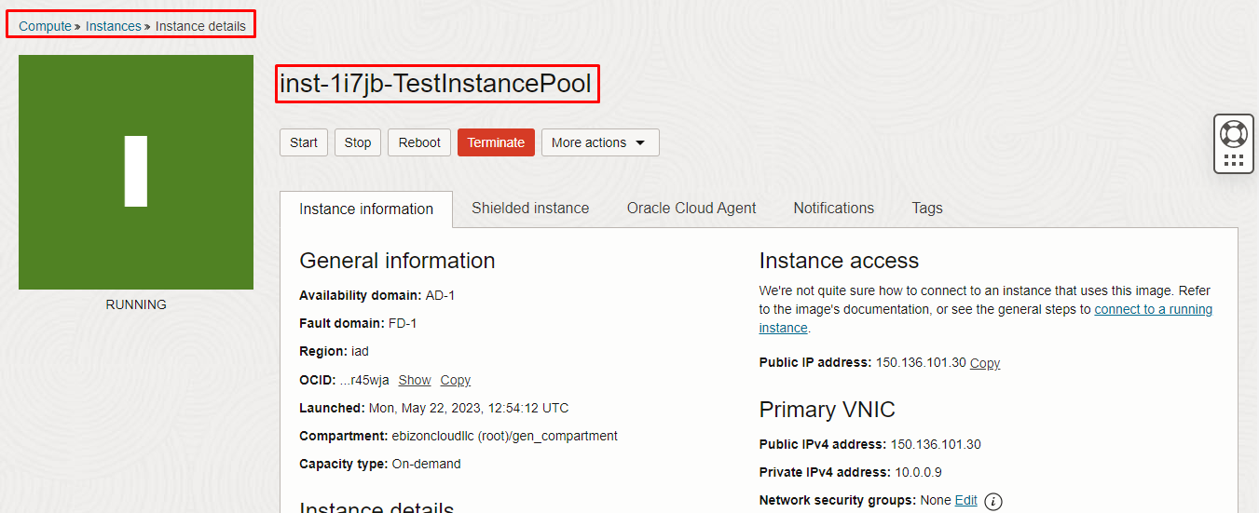
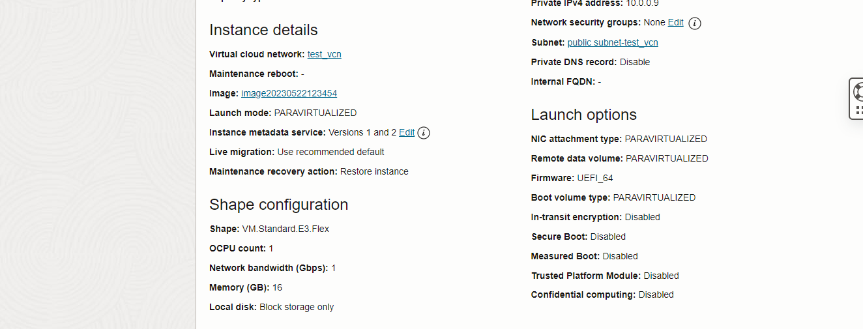
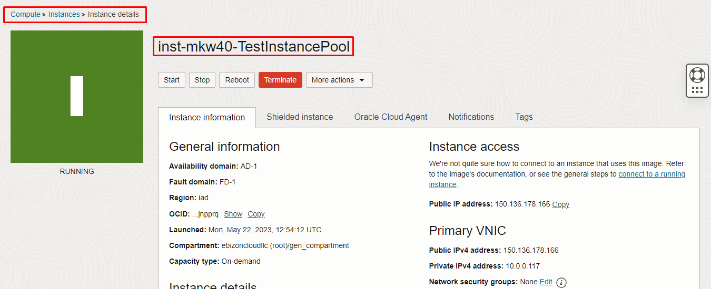

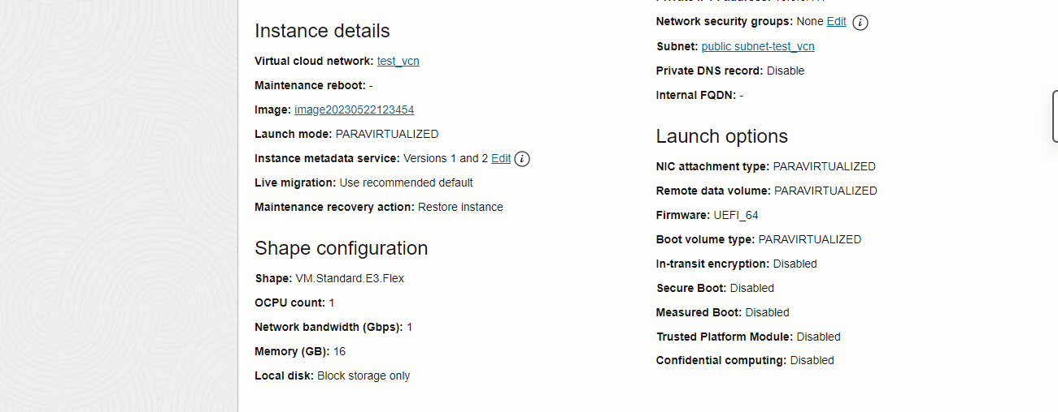

Compute Instance Configuration Instance Configuration Details
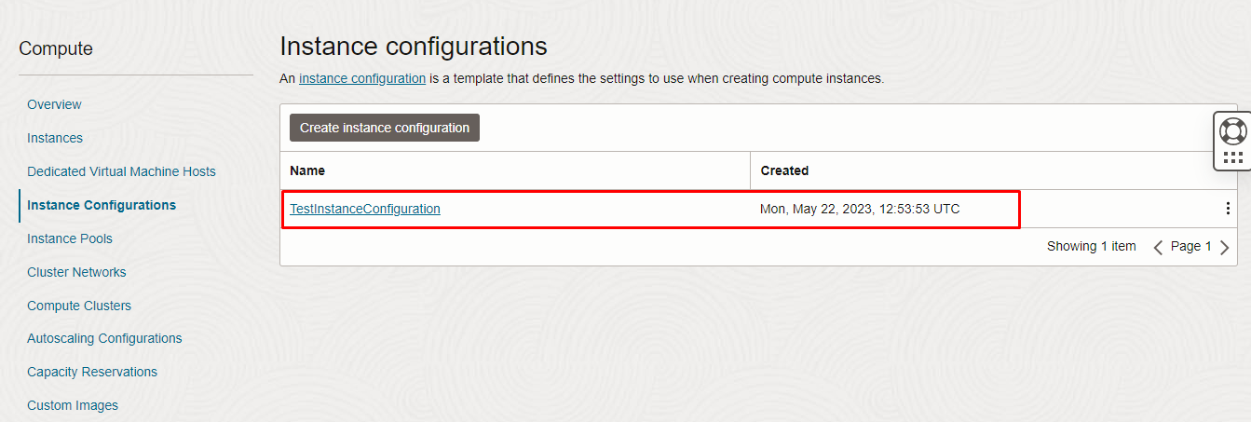
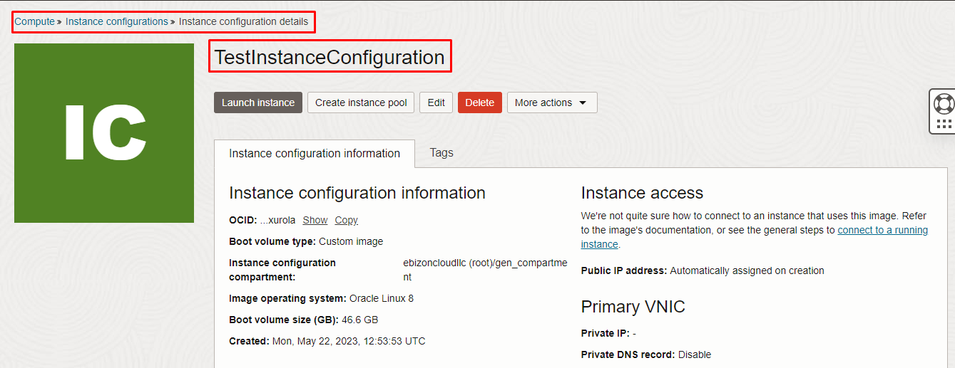
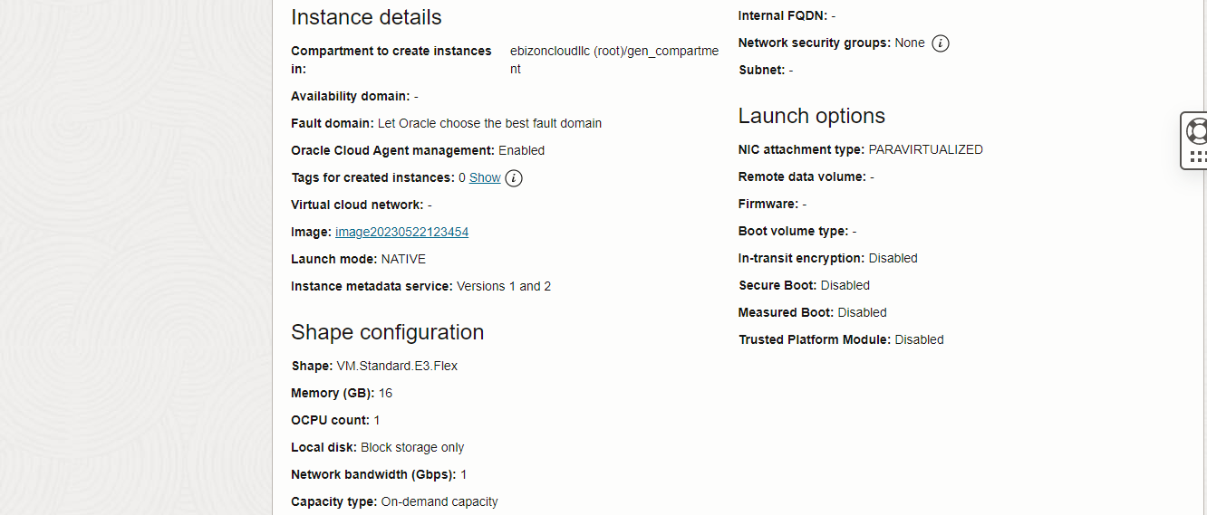
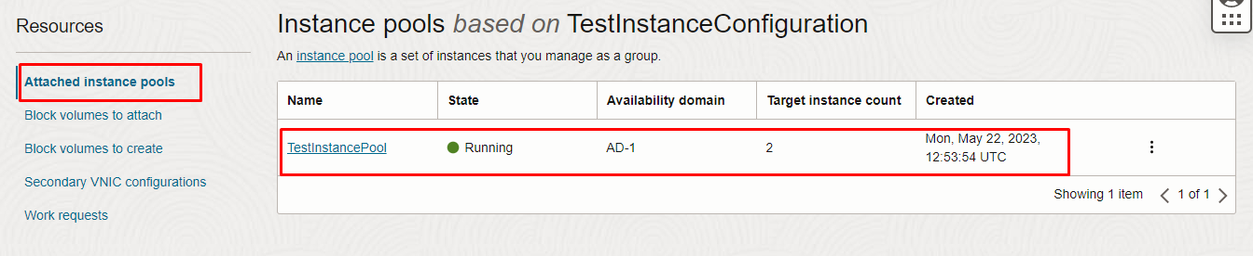

Compute Instance Pool Instance Pool Details
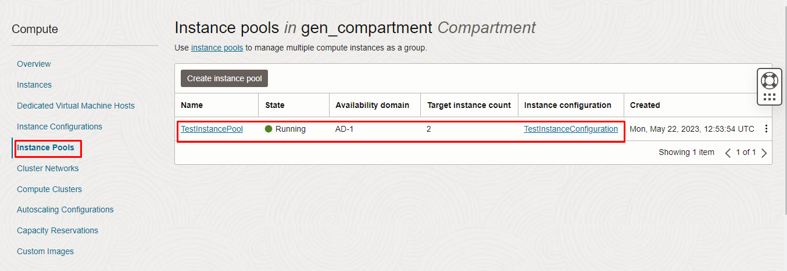

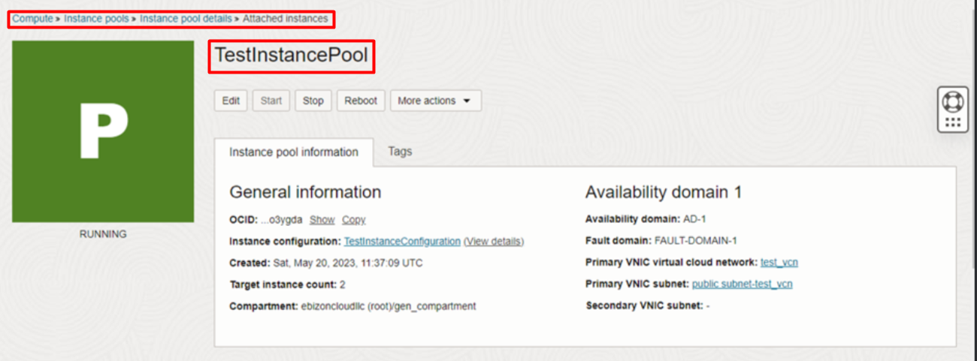

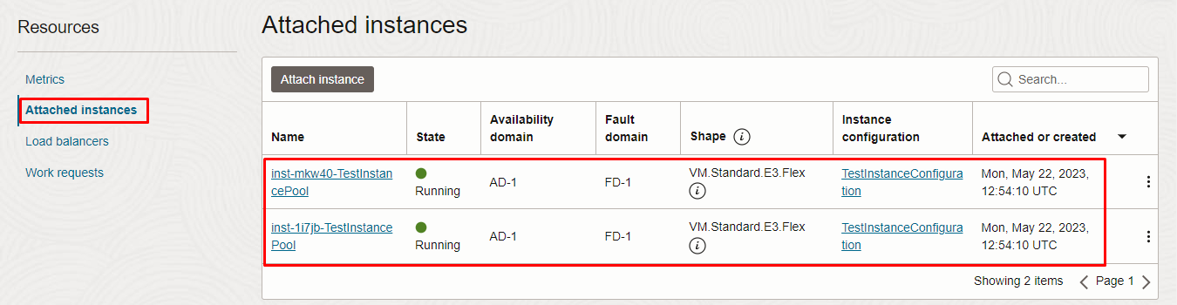

Destroy the stack
Create a destroy job in Resource Manager to release resources associated with a stack and clean up the tenancy. Once destroyed data cannot be recovered from resources.

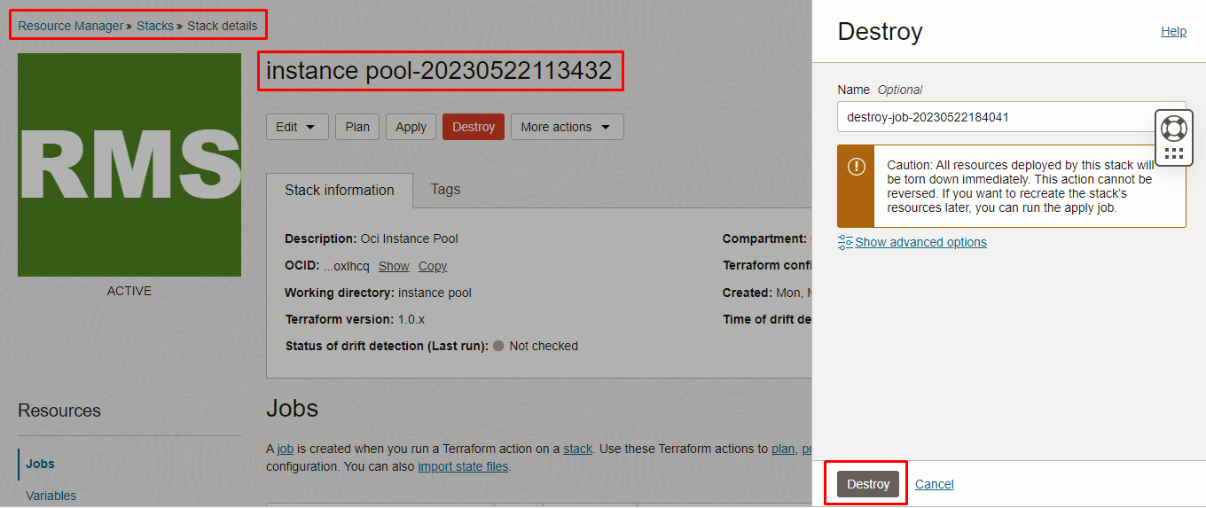

#END#

